Postpone Deadline

Each Chair can postpone the deadline for one of the following actions : bidding, review and submit. The chair must be logged in and he must be registered with the role of a chair in that conference.

Step by step:

1.Double click on the required conference from the list of conferences

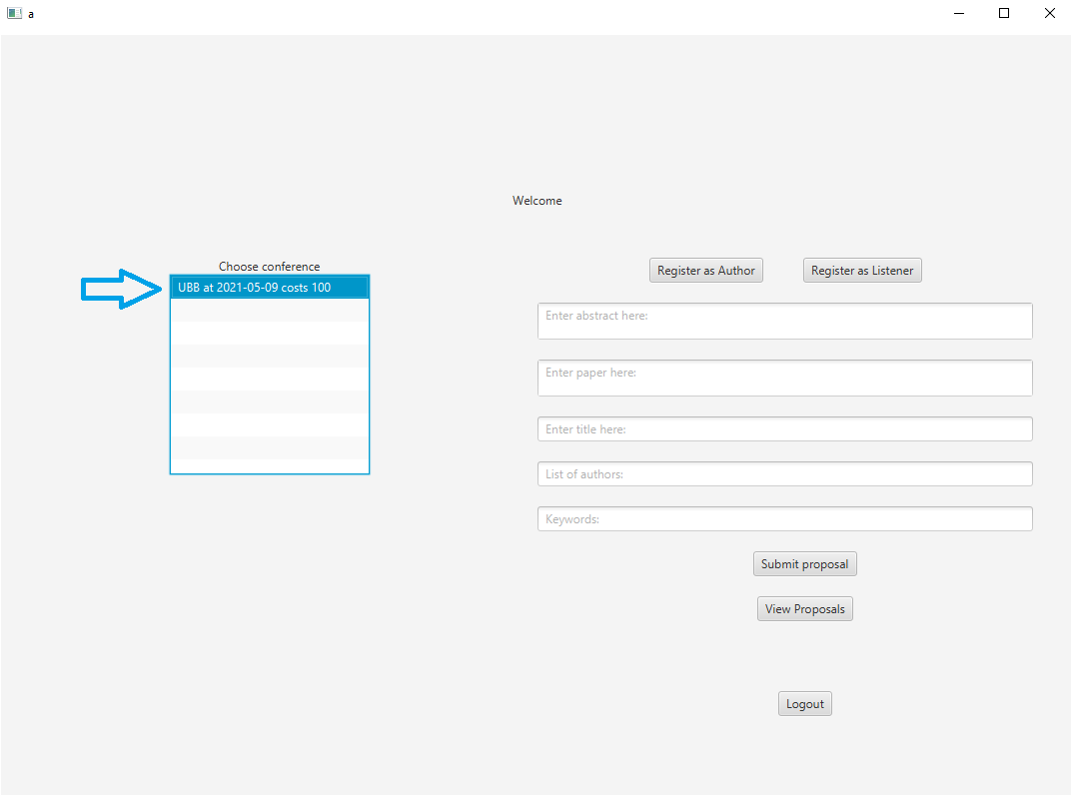

2. Double click on “CHAIR” role



3.Click the “Postpone deadlines” button.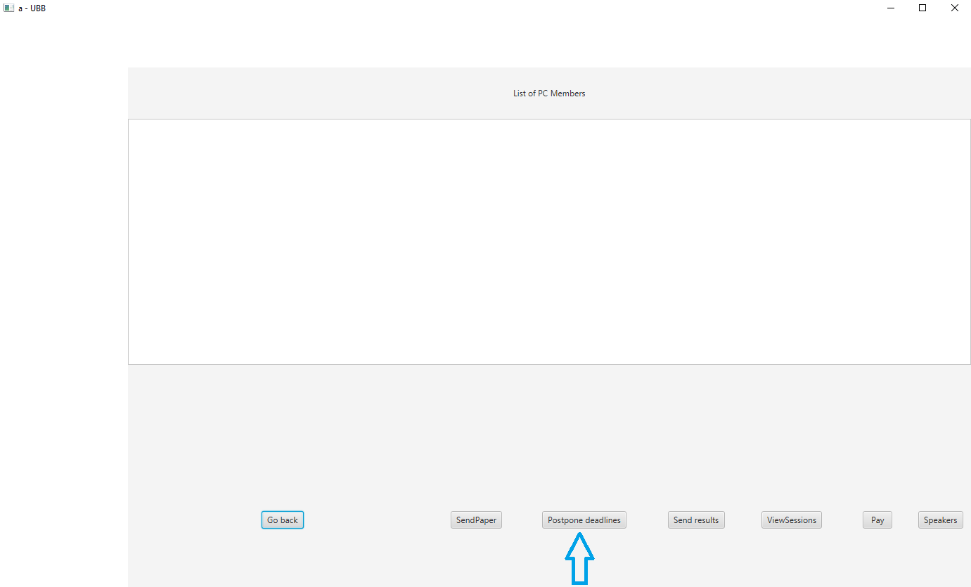

4.1. The chair can see the current deadline for the submit action. He can modify the current deadline by selecting a new date from the calendar and pressing the “Postpone submit deadline”.

4.2.The chair can see the current deadline for the review action. He can modify the current deadline by selecting a new date from the calendar and pressing the “Postpone review deadline”.

4.3.The chair can see the current deadline for the bidding action. He can modify the current deadline by selecting a new date from the calendar and pressing the “Postpone bidding deadline”.

